TIPS FOR LOCALIZING
***FOR MARKETS: Consider swapping out one of the destinations for another region within your market that is known for hosting Oktoberfest celebrations. For relevant data, please check the All Survey Document on Box.

The following Booking.com business priorities are reflected in this pitch:
- Connected Trip (attractions, cars)
- Homes
- US

Please check that these Homes and Attractions are still available to book within the 90-day period.

As always, please share content with your day-to-day Booking.com contact for final approval***

Prost! Oktoberfest Around the World

From Munich’s iconic beer tents to sausage races in Cincinnati and half-liter beer drinking contests in Brazil, Oktoberfest, the two-week German folk festival and beer celebration (taking place this year from 20 September - 5 October in Munich), has grown into one of the world’s most beloved cultural exports. While the Bavarian capital still hosts the largest and most famous celebration, cities across the globe have embraced the tradition, infusing it with their own local flavors, customs, and settings. With 45%* of global travelers wanting to experience a cultural event while traveling, Booking.com is spotlighting some of the most spirited Oktoberfest celebrations that prove you don’t have to be in Munich to raise a stein and shout “Prost”!

Cincinnati, Ohio, USA (18–21 September, 2025)
In the American Midwest, Cincinnati transforms its downtown streets into one of the largest Oktoberfest celebrations outside of Germany, Oktoberfest Zinzinnati, drawing around half a million revelers each year. For three days, the city’s streets are transformed into a Bavarian-style beer garden, with more than 100 varieties of beer, German folk music, and an astonishing array of sausages and sauerkraut to feast to the heart's content. The highlight? The Running of the Wieners, where dachshunds in hotdog costumes race for glory. From chicken dance world records to cream puff eating contests, Cincinnati’s Oktoberfest is as playful as it is authentic, a true celebration of the city’s German-heritage, having attracted immigrants of German origin in the 1930s thanks to its thriving meatpacking and shipping industries. Between rounds, travelers can stroll along the scenic Ohio River, explore the art and architecture of the Over-the-Rhine district, or dip into the city’s thriving craft brewery scene, and venture on a brewery caverns tour, to discover just how Cincinnati keeps the beer flowing long after the festival ends.
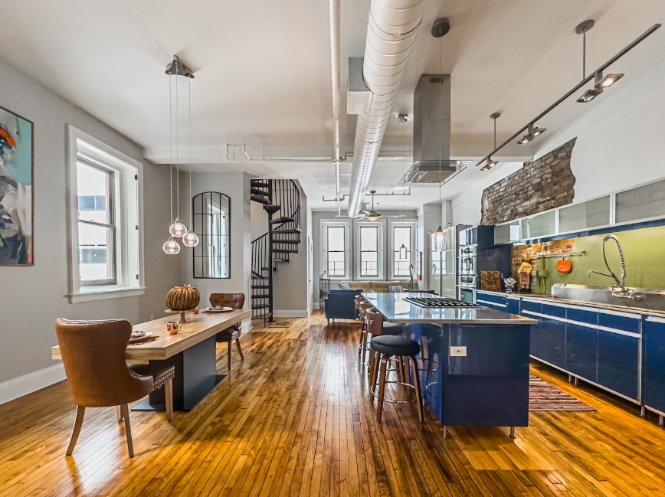
Where to stay: The Historic Lyric Penthouse with Private Rooftop offers a sleek, modern apartment escape in the heart of the city’s downtown. This property’s stylish interiors, boasting a double bedroom, two living spaces, an open plan kitchen area, and private rooftop terrace are perfect for taking in city views, and taking a breather after a weekend of Oktoberfest festivities.

Blumenau, Santa Catarina, Brazil (8–26 October, 2025)
The city of Blumenau in Brazil’s southern state of Santa Catarina proudly wears its German heritage on its sleeve. In October, that sleeve is often attached to a dirndl or lederhosen. Founded by German immigrants in the mid-19th century, Blumenau hosts Latin America’s largest Oktoberfest, complete with sprawling beer tents, traditional folk dancing, and hearty German fare. The 18-day festival takes over the city with daily parades, oompah bands, and the Rei do Chopp (King of Beer) competition, where contestants race to finish half-liter mugs without spilling a drop. Let the celebration continue with a guided Beer Tasting Experience just a short drive away from the city centre where travelers can learn a true lesson in beer, sampling a selection of award-winning Pilsen, Hop Lager, IPA and Weiss, among others. Between steins, visitors can wander the charming German-style architecture of the city center, stroll along the banks of the Itajaí-Açu River, or explore the nearby Serra do Itajaí mountains for lush hiking trails.

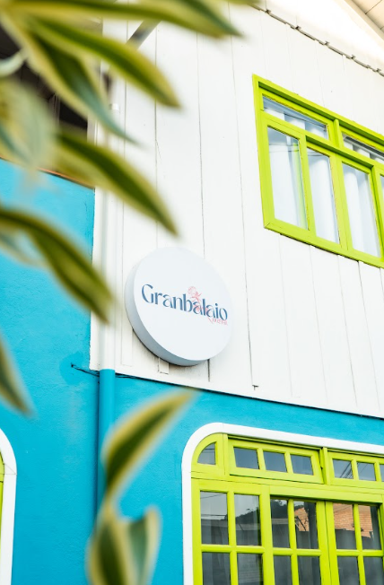
Where to stay: Set within easy reach of Vila Germânica Park, Latin America’s largest amusement park, Granbalaio Hostel offers a budget-conscious option that keeps guests close to Blumenau’s Oktoberfest buzz. Air-conditioned rooms, a shared kitchen, and leafy garden spaces provide a comfortable base to unwind after a day of festival fun, while the added option of a walking tour organised by the property allows travelers to explore all this city has to offer.

Kitchener-Waterloo, Ontario, Canada (26 September–18 October, 2025)
Once known as “Berlin,” the region in Ontario, Kitchener-Waterloo, has roots that run deep into German heritage, and each autumn, those roots blossom into Canada’s largest Oktoberfest celebration. Spanning nearly a month, the festival turns the twin cities into a celebration of Bavarian culture, with bustling beer halls, accordion-led singalongs, and hearty dishes from schnitzel to brezn, the German word for a pretzel. Signature events include the much-loved Thanksgiving Day Parade, broadcast to millions, and lively keg-tapping ceremonies that get the crowds roaring. True to Canadian hospitality, the festival offers plenty for families too, with community concerts, cultural performances, and markets filled with local crafts. Outside the beer halls, visitors can explore the vibrant St. Jacobs Farmers’ Market, take a scenic autumn drive through golden-hued countryside, or venture into nearby Mennonite country for a glimpse into life at a gentler pace. For a Canadian twist on Bavarian cheer, try a maple-infused brew, proof that Oktoberfest can be both old-world and proudly local.
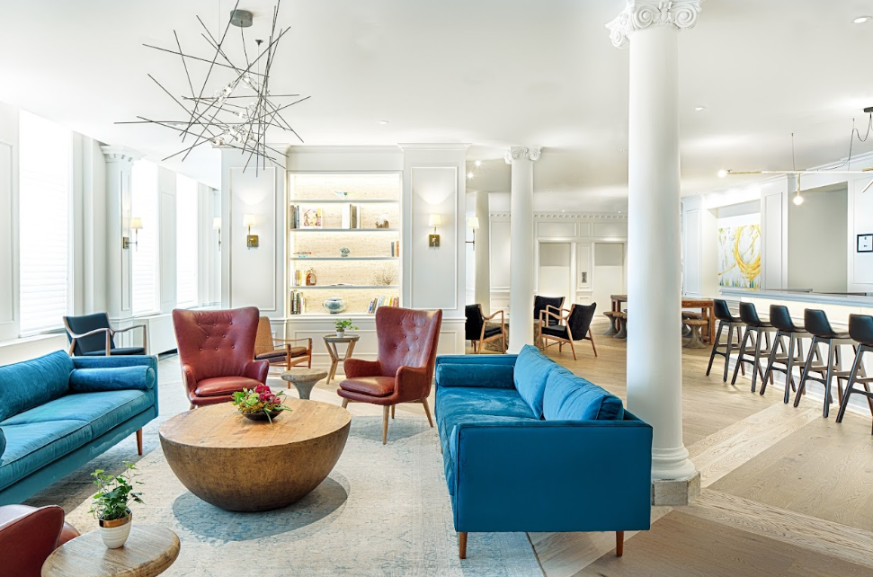
Where to stay: The Walper Hotel is a beautifully restored 1893 boutique property that blends Victorian charm with sleek, contemporary design. Guests can enjoy inviting, spacious rooms, and a modern onsite restaurant, serving lunch, dinner and a weekend brunch (to help get the party started!). Located just steps from the festival and with plenty of shopping, dining and entertainment options nearby for guests to enjoy beyond the festival fun.

Zurich, Switzerland (9–25 October, 2025)
In true Swiss style, Zurich’s Oktoberfest blends precision with panache, stretching for close to a month of Bavarian cheer on the shores of Lake Zurich. Giant beer tents spring to life, the largest being the famed Bauschänzli, a city-centre hub. Golden lagers flow in generous steins, traditional bands keep the oompah beats steady and the scent of roast chicken and pretzels fills the air. Here, Bavarian traditions meet Swiss touches, from alpine cheese platters to crisp local lagers brewed with mountain spring water. Between festivities, Zurich’s charms are plentiful: wander the cobbled streets of the Old Town, hop on a tram to the Uetliberg for panoramic vistas over the city, cruise across the sparkling lake, or take a half-day trip to the thundering Rhine Falls for a refreshing dose of nature. For those seeking alpine adventures, nearby Mount Titlis offers glacier views and cable car rides that are just as exhilarating as a festival dance floor. Don’t miss out on visiting some of the city’s renowned chocolate shops, artisanal coffee spots and luxury boutiques while exploring the city as well.
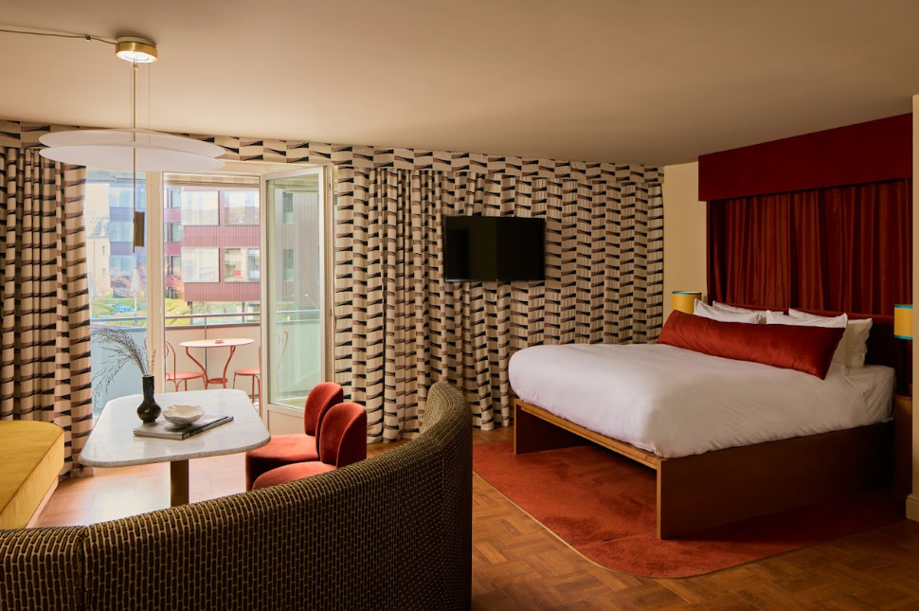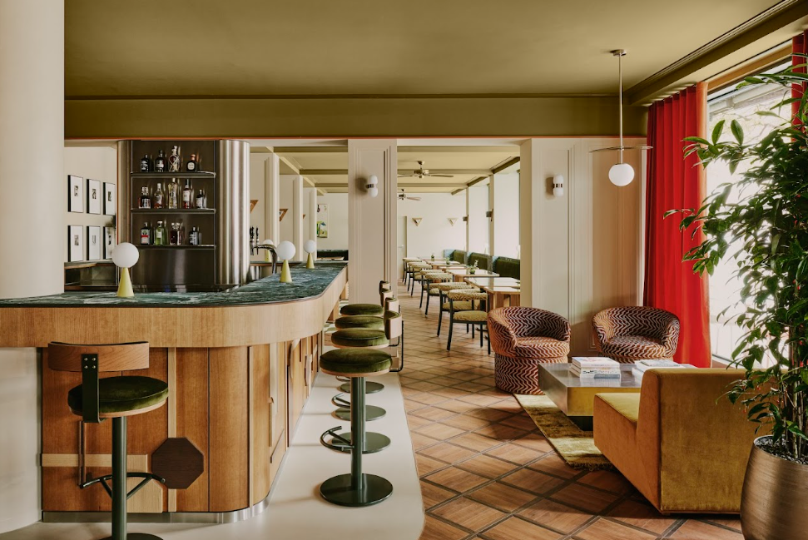
Where to stay: Locke am Platz offers a Riviera-inspired retreat in Zurich’s elegant Enge district. Just minutes from the lake, and the central areas of town (Fraumünster and Bahnhofstrasse), this property’s bright, modern interiors and relaxed social spaces make it the ideal base for beer drinkers who also want to explore the city’s cultural landmarks.

*Research was commissioned by Booking.com and independently conducted among a sample of adults who had taken a leisure trip in the last 12 months with an overnight stay and plan to travel in 2025. The sample comprised 32,106 respondents across 32 markets surveyed in January 2025. USA N=2,000, Canada N=800, Spain N=800, Italy N=800, France N=1800, UK N=1800, Germany N=1800, Netherlands N=800, Denmark N=500, Sweden N=500, Croatia N=501, Switzerland N=800, Belgium N=800, Ireland N=504, Austria N=500, Portugal N=800, Mexico N=1,800, Colombia N=800, Brazil N=1,800, Argentina N=800, India N=1,800, China N=800, Hong Kong N=500, Thailand N=800, Singapore N=800, Taiwan N=500, Vietnam N=800, South Korea N=800, Japan N=1,800, UAE N=500, Australia N=1,800, New Zealand N=500.

